March 2025 |  |  |  |  | 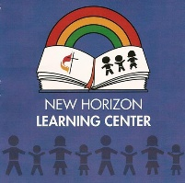
SUNDAY | MONDAY | TUESDAY | WEDNESDAY | THURSDAY | FRIDAY | SATURDAY
23 | 24 | 25 | 26 | 27 | 28 | 1
2 | 3 | 4 | 5 | 6 | 7 | 8
  Dr. Seuss, Nursery Rhymes and Fairy Tales   | Petting Zoo    9-11:30   |  |  |  | VPK Graduation Pictures  
9 | 10 | 11 | 12 | 13 | 14 | 15
Spring

16 | 17 | 18 | 19 | 20 | 21 | 22
Art Appreciation   |   Spirit Day:  St. Patrick's Day |  |  |  | No VPK: Open VPK Camp and Preschool Only
23 | 24 | 25 | 26 | 27 | 28 | 29
Spring Break Camp

30 | 31 | NOTES:
Space


© EditableCalendar.Com

